www.vivavda.it
The Activities - Sportsmen
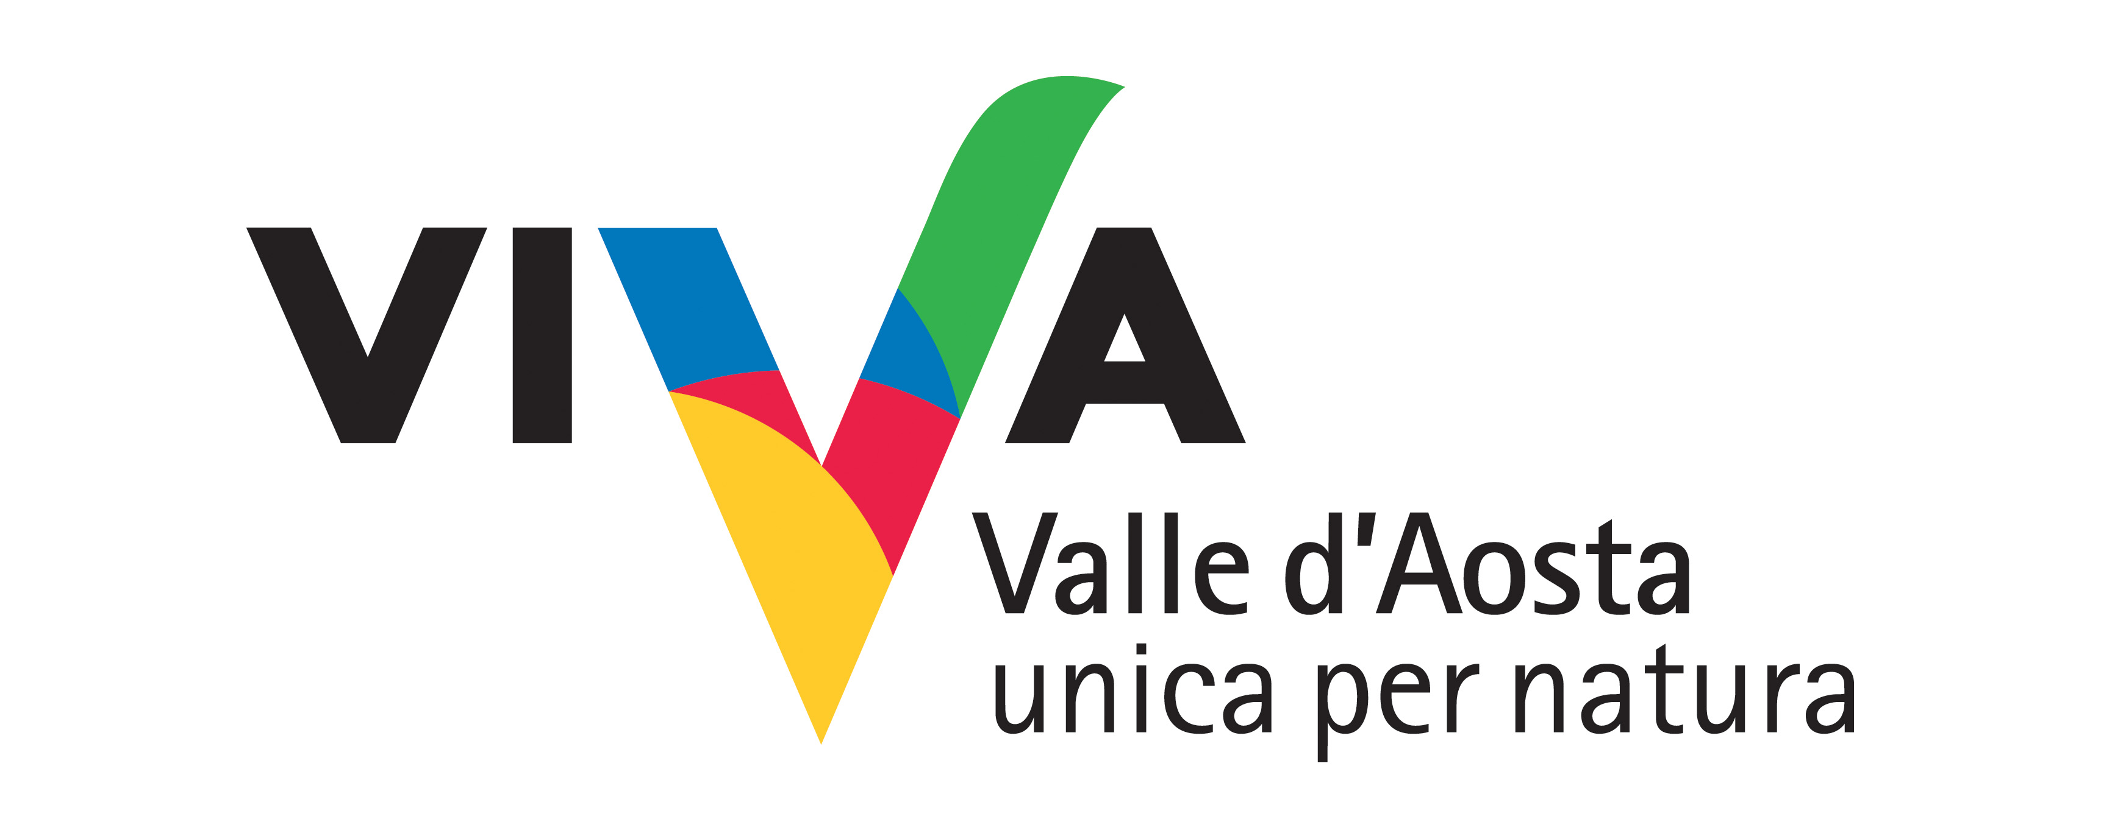
A relaxed weekend... of thrills

Trekking and canyoning in the Mont Avic and Mont Emilius SPA (special protection area) and in the Mont Avic Nature Park. Together with the pleasure of the conventional nature hike is added the excitement of descending an Alpine stream. A headlong dive into the green of a regional area that, by its position and its geology and soil, is home to really unique botanical species.

Where:
Valley of Clavalité
The Mont Avic natural Park

Duration of activity and period recommended:
2 days
July – August

No. of participants and age groups:
Min. 4 Max 12
Adults

Physical preparation and equipment:
Good physical health.
Clothing for trekking.
The equipment for canyoning is provided by the canyoning school instructors.

Professionals involved:
Canyoning instructor and Nature Guide.

PROGRAM
Departure from Clavalité in the town of Fénis, in the early afternoon and arrival at the refuge Barbustel for dinner and overnight. In the morning, breakfast at the refuge, down in the Mont Avic Park up to Covarey, meeting with the instructor and canyoning down the river Chalamy. Lunch Covarey. Opportunity to visit the Visitors Centre of Park.

INFO
Sac-à-dos
Associazione Sportiva e Dilettantistica
Fraz. SINSEIN, 16 - 11020 ST MARCEL (AO) ITALY
Andrea BIONAZ cell. +39 338 6715978
info@sacados.it
www.sacados.it

COSTS
180 euro per person.
Including half board in refuge, lunch after canyoning activities, guide and instructor.

Timing and conditions of booking
One week prior to the month of July, at least 15 days prior to the month of August.

