www.vivavda.it
Activities / Family
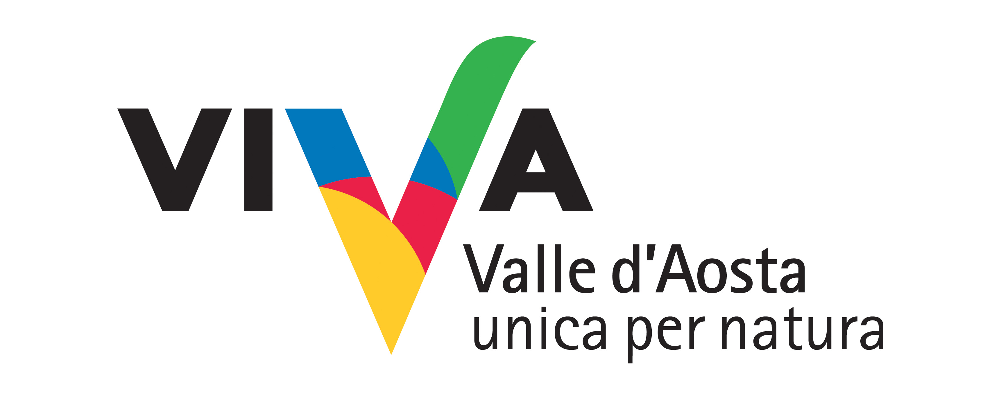
Having fun with miners-actors

An open-air theatre – a mining site – where you are both spectators and actors in a guided tour that provides a unique emotional experience of music and theatre to enter the mineral world. Stories are told by the characters, and the possibility is given of touching and feeling the mineral components of the Earth and discovering the geology and mining history of the site..

Where:
Mont Avic and Mont Emilius
(ville de Saint-Marcel, Mineral Park of Chuc-Servette)

Duration of activity and period recommended:
3 hours for trekking with theatrical pieces + transit time (½ hour)
Juin to Septembre

No. of participants and age groups:
Max 25 (in the case of organised groups)
From schoolchildren to people aged 80, based on physical fitness.

Physical preparation and equipment:
Medium-low level.
Basic requirements for mountain trekking: walking sticks, backpack, heavy boots, mountain clothes. No public transport available.

Equipment required:
helmet with front torch. Material included in the price.

Professionals involved:
Nature hike guides, actors, theatre group.

PROGRAM
Because the performances take place "surprise", it provides a brief introductory experience that will give particular guidance on how to move in Mineral Park.

INFO
Sac-à-dos
Associazione Sportiva e Dilettantistica
Fraz. SINSEIN, 16 - 11020 ST MARCEL (AO) ITALY
Andrea BIONAZ cell. +39 338 6715978
info@sacados.it
www.sacados.it

COSTS
15 euro per person: (for Nature hike guides)
to redefine the cost theater
20 euro per person: dinner in a typical
Total Euro 35 per person

Timing and conditions of booking
Reservation required at the association reference.

