www.vivavda.it
Activities - Fans
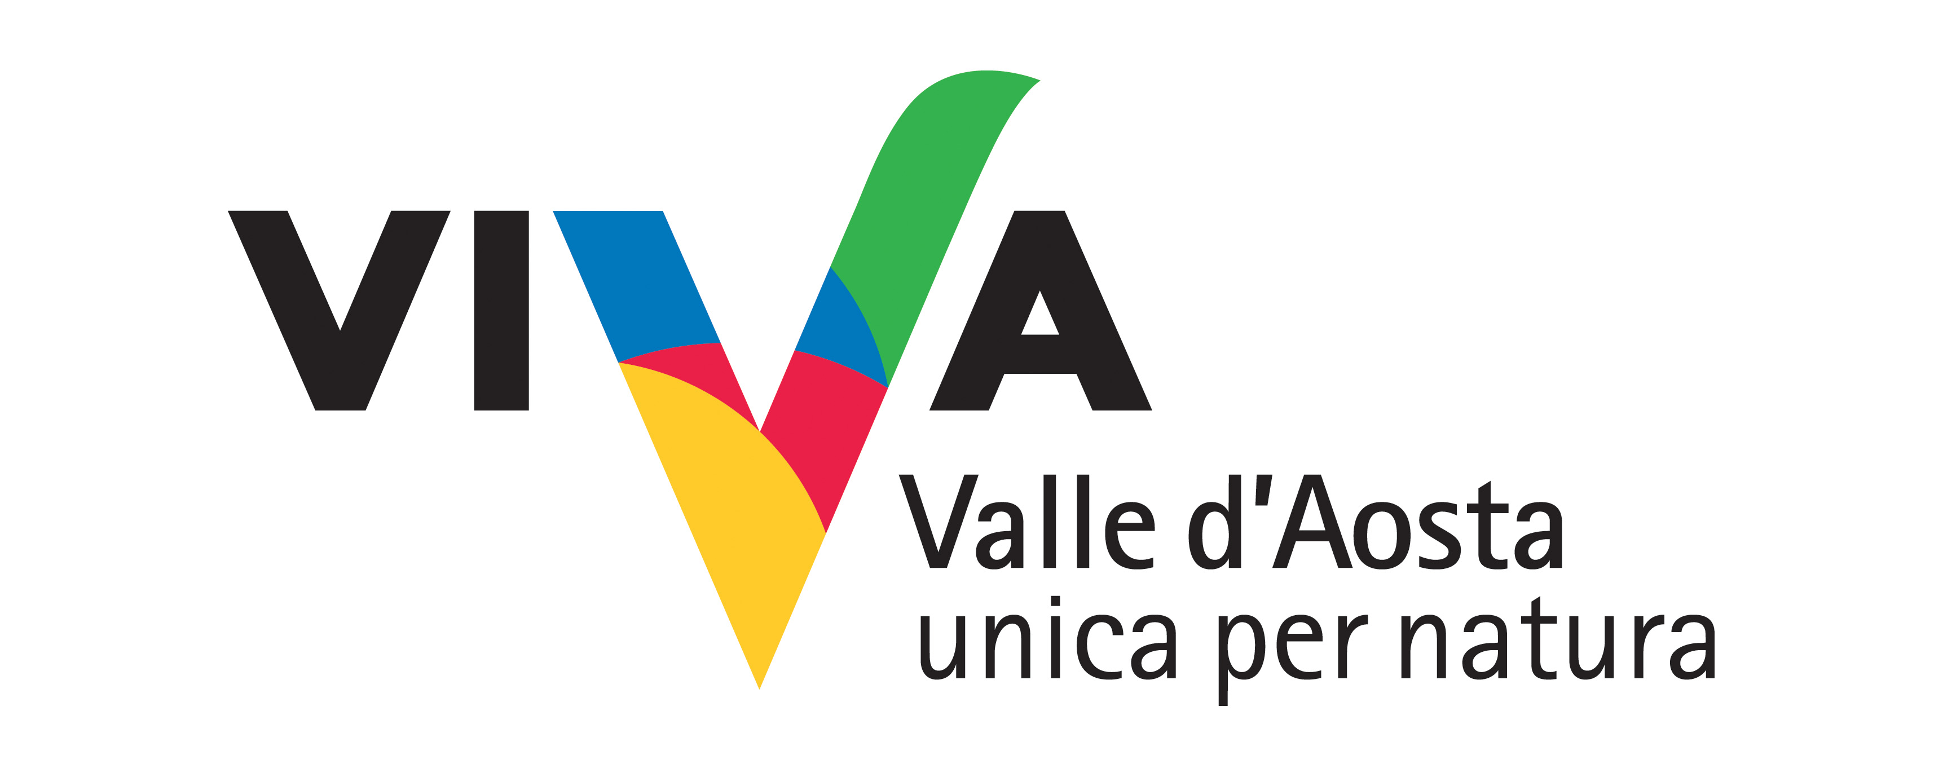
Objective: park

How can a passion for photography and nature be merged? By becoming news photographers for a day. The camera will be the means through which to discreetly observe chamois and ibex in the mating season; personal contact with a gentle, environmentally-friendly approach.
With the help of a nature guide and a professional photographer, you’ll be able to turn a simple excursion into a unique experience.

Where:
Gran Paradiso National Park (Valle d’Aosta)
The Mont Avic natural Park
The Mont Mars Natural Reserve
Val Ferret

Duration of activity and period recommended:
1 day
From November to January

No. of participants and age groups:
Min. 6 Max 15
From ages 14

Physical preparation and equipment:
No training or preparation required, good physical condition.
Dress appropriately.
Own photographic equipment.
Possibility of private minibus from the bottom or from the accommodation.

Professionals involved:
Nature hike guide, photographer

PROGRAM
The activity will be preceded by a brief introduction that will explain to participants how to move and behave in the day and how to use the necessary tools. Photography as a privileged mode of observation to understand the complexity of the natural environment and learn important concepts such as environmental protection and respect.

INFO
HABITAT
Sede operativa: Via E. Aubert, 48 - 11100 Aosta Italia
Tel. e Fax 0165/363851
info@ambientenatura.com
www.ambientenatura.com

COSTS
20,00 euro per person
30,00 euro per person with transport minibus

Timing and conditions of booking
Booking at the association.

