www.vivavda.it
Activities / Family
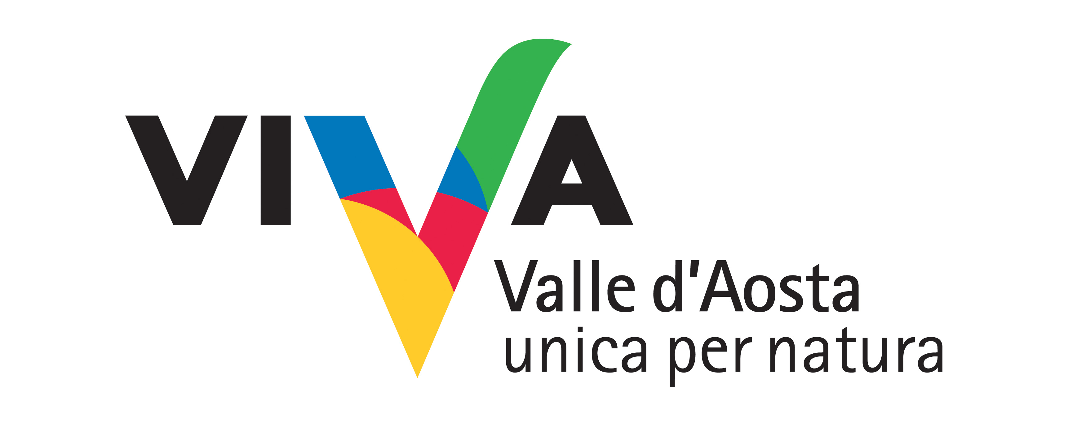
Tender is the night

Every night the spectacle is repeated: Orion threatens Taurus the Bull with his stick and ambushes Pleiades, Cassiopeia flaunts her beauty, Sirius shines in Canis Major and all the stars look on. A guide will help you recognise the main constellations, telling you about the legends and secrets of astronomy.

Where:
Gran Paradiso National Park (Valle d’Aosta), The Mont Avic Natural Park, Mont Mars, Val Ferret, Tsatelet, Lake of Villa Natural Reserve

Duration of activity and period recommended:
about 3/4 hours
all year round

No. of participants and age groups:
Min. 5
Adults / families

Physical preparation and equipment:
None. Equipment required:Material included in the price.

Equipment required:
Any other material necessary will be provided during the course .

Professionals involved:
Nature guide specializing in astronomy (a popular level).

PROGRAM
Combining observation of wildlife with observation of the sky: details of an uncommon experience together with the aspects specific to the territory (and lastly, supper made from locally grown produce).

INFO
HABITAT
Sede operativa: Via E. Aubert, 48 - 11100 Aosta Italia
Tel. e Fax 0165/363851
info@ambientenatura.com
www.ambientenatura.com

COSTS
Euro 15.00 per person (including accident insurance)
Dinner at local restaurant included
12/15 euros / person for a snack with typical post activities

Timing and conditions of booking
At the coooperativa reference.

