www.vivavda.it
Activities / Family
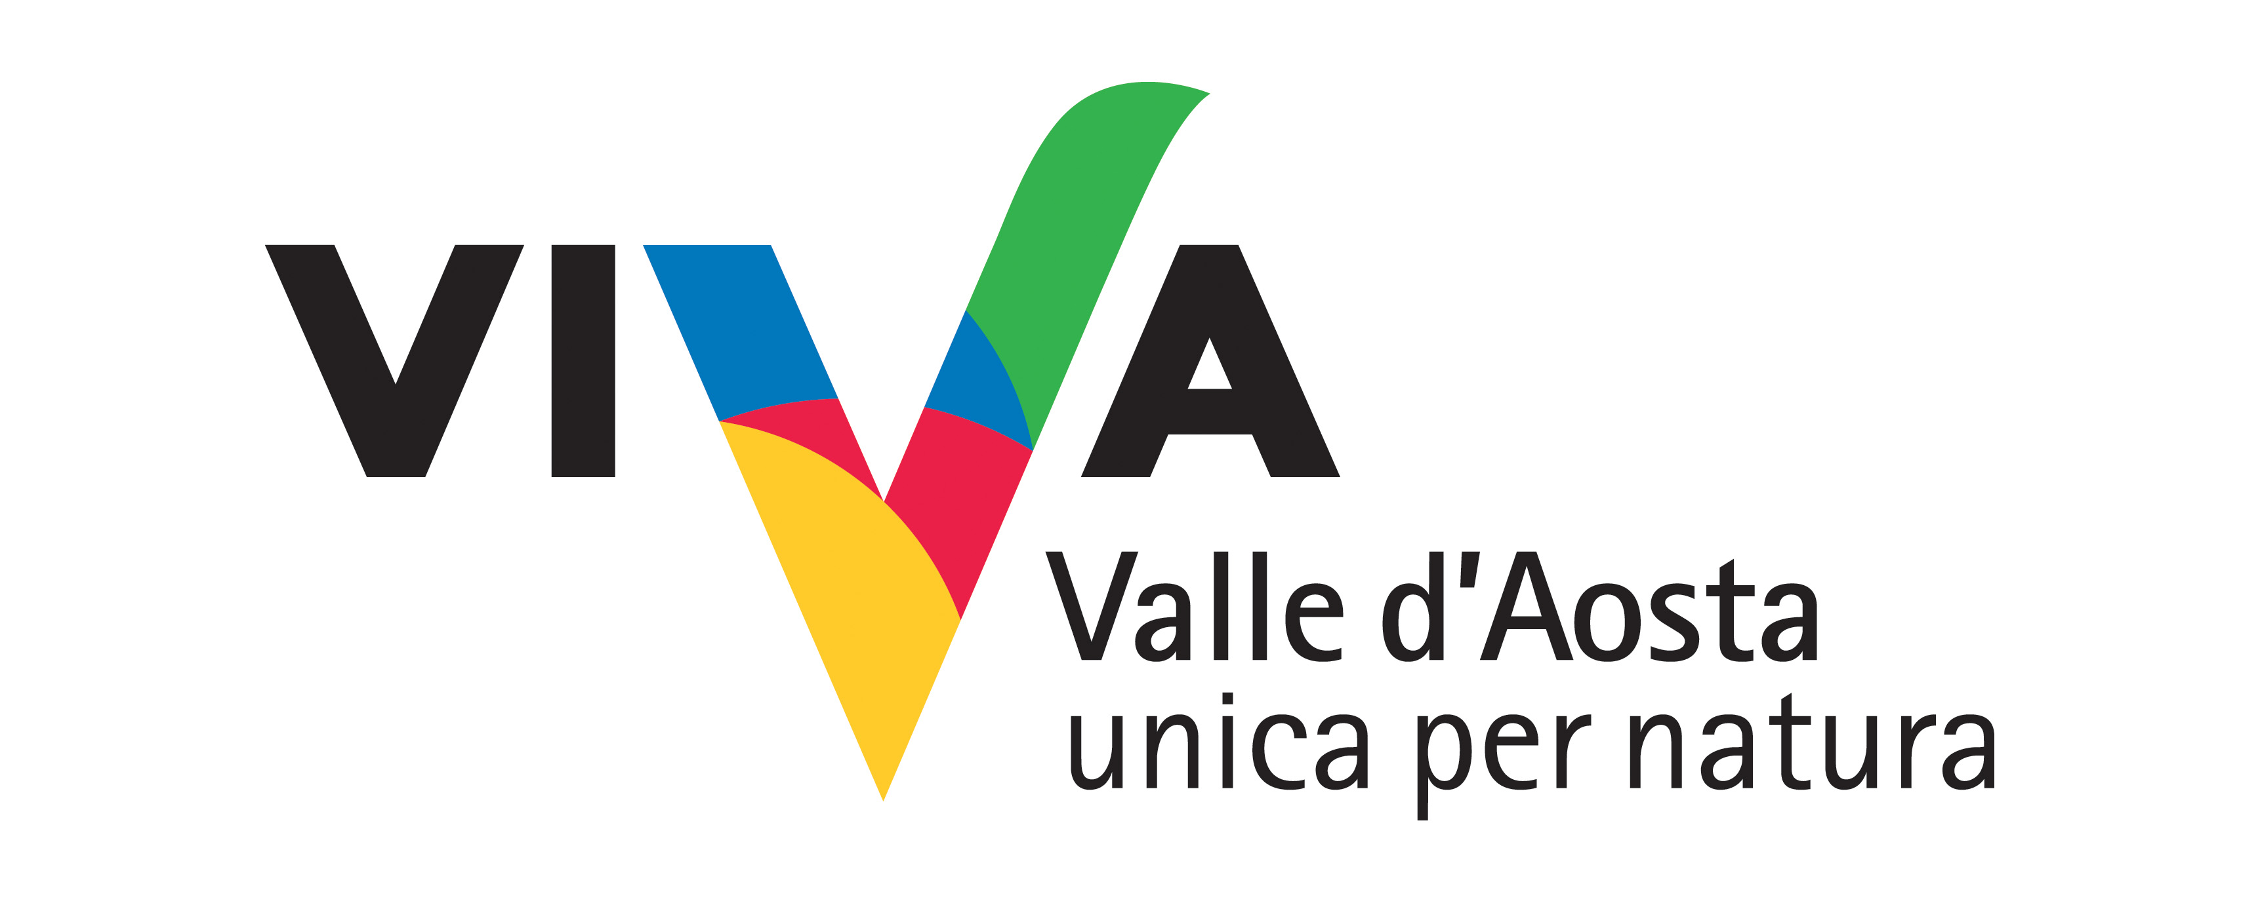
The 5 ways of the senses

Children and adults taken on a journey for reawakening the five senses in order to properly “interpret” Nature and fully perceive its beauty and uniqueness. An awareness-heightening expedition consisting of games, experiments and occasional exciting moments.
An experience full of stimuli: colours and forms, with sounds, smells and sensations.

Where:
Wildlife reserves
Lake of Villa (Challand-Saint-Victor)
Les Iles (Saint-Marcel / Brissogne)
Marais (Morgex-La Salle)

Duration of activity and period recommended:
1 or 2 half days lasting 2½ hours each
From May to September

No. of participants and age groups:
Min. 16 Max 20
From ages 6 to 11

Physical preparation and equipment:
None.
No specific personal equipment is required, but comfortable clothes and sturdy footwear (not sandals) are recommended.
Equipment required: The material necessary for the activity (consumables and equipment) will be supplied to participants and is therefore included in the price.

Professionals involved:
Instructor-entertainer expert in teaching about the environment

PROGRAM
1 HALF DAY
duration 2½ hours each (location of the 5 senses concentrated and self on the only site selected)
2 HALF DAYS
duration 2½ hours each, joined together in a full day or on two consecutive days or not consecutive, with the possibility of developing the path on two different sites to be chosen, allowing a higher more breathing the topics covered and on the other a comparison between seemingly similar environments.

INFO
Cooperativa Rhiannon
Località La Grenade 67, 11010 Sarre (AO)
Tel e Fax: 0165 554998
m.garrone@rhiannonvda.it - f.yoccoz@rhiannonvda.it
www.rhiannonvda.it

COSTS
FAMILIES: euro 16 adult and child (maximum 3 children per adult); euro 7 additional child.
ORGANIZED GROUPS: Euro 140 flat rate; Free - accompanying adults; maximum number of participants (children): 20; minimum number at the discretion of the customer.
PRIMARY SCHOOLS: Euro 150 flat rate (up to 25 children), Euro 250 additional operator (max 50 participants); free - adults and accompanying.
RATES TOUR OPERATOR: Euro 130 + VAT 4% flat rate (up to 25 children); Euro 216 + VAT 4% additional operator (max 50 participants); free - adults and accompanying (VAT reduced rate to 4% for educational activities aimed at children).

Timing and conditions of booking
The laboratory is part of the catalog of the Cooperative Rhiannon and provides for an advance booking directly with the Cooperative. The laboratory can be purchased by private individuals, groups, and commercial tour operators.

