www.vivavda.it
The Activities - Sportsmen
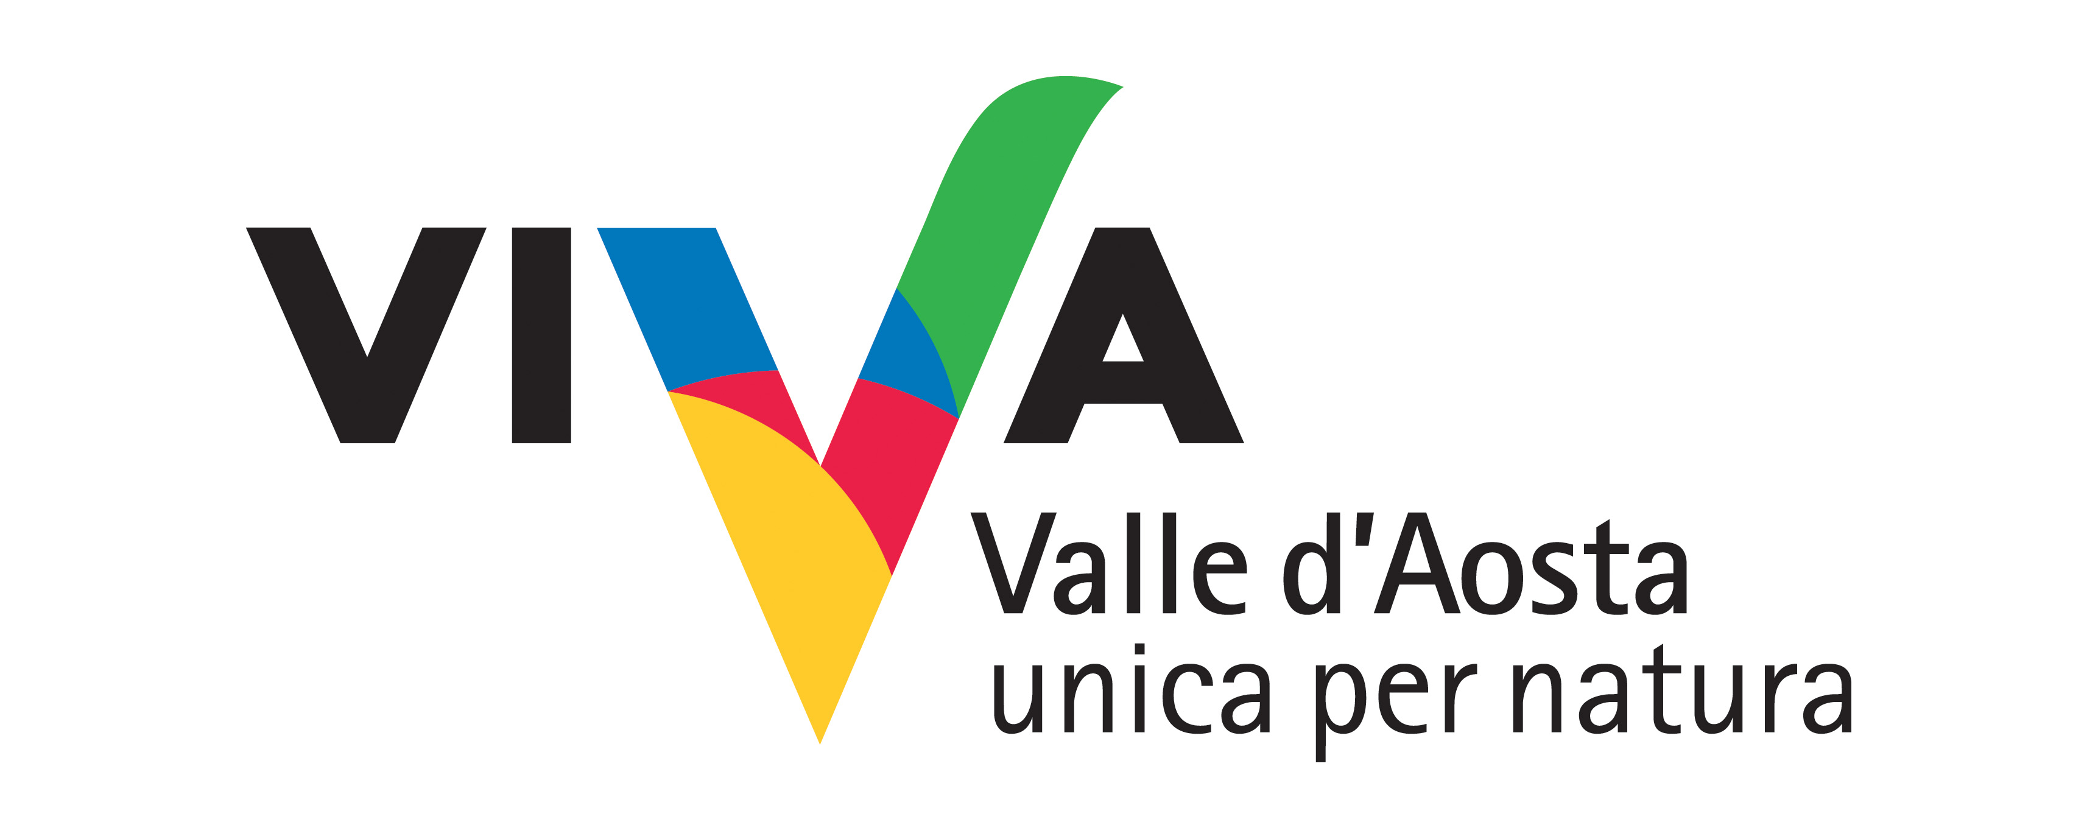
The devil’s cage: the valley of Grauson

No other place in the Valle d’Aosta is so interesting in terms of flowers due to the presence of glacial relicts and native plants typical to the Alpine environment as the Grauson Valley. An excursion in this valley means being immersed in a wild territory, dominated by nature and by a strong sense of spirituality that permeates the numerous legends of the Valley, like that of Bécquet de Tarabouq, a chapel in which it is said that St Bernard has locked up no less than the Devil himself.

Where:
Valle di Cogne - Valley of Grauson

Duration of activity and period recommended:
1 day
June to September

No. of participants and age groups:
Min. 8 Max 25
From 8 to 75 years

Physical preparation and equipment:
Good level
Equipment for trekking and packed lunch

Professionals involved:
Nature hike guides

PROGRAM
Gimillan, Lacs de Lussert - Duration: 7.00 h - Difference in altitude: 1000 m 4-6 km

INFO
Associazione Guide della Natura di Cogne
Via Bourgeois, 33 - 11012 COGNE (AO) Valle d’Aosta - ITALIA
Tel: +39 0165.74835
info@cogneturismo.it
www.guidenaturacogne.net

COSTS
15 euro per participant. For the packed lunch the food is not provided by the association.

Timing and conditions of booking
At the association of reference at least 5 days before.

